UNL Department of Agronomy & Horticulture
Curriculum Coordinating Committee Minutes
Monday, May 23, 2011, 3 p.m.
279M PLSH

Call to Order

The meeting was opened by Mark Lagrimini at 3 p.m. in 279M PLSH. Members in attendance were: Steve Mason, Dennis McCallister, Ellen Paparozzi, Richard Ferguson, Martha Mamo (CASNR rep.), and Kathy Schindler, recorder.

AGRO 269 Staffing
AGRO 269, Principles of Soil Management, was previously taught by Dr. Dan Walters. Last year after Dr. Walters’ death, it was taught by Brigid Amos, a post doctoral employee, who studied with Dr. Walters. Committee members were not sure Dr. Amos wants to continue teaching the course.
One suggestion is to ask Terry Loecke, a new research assistant professor in SNR, to teach the course. Dr. Lagrimini said he would find out Dr. Loecke’s phone number and when he arrives in Lincoln. Dr. Lagrimini, Dr. Mamo, and Dr. McCallister said they would like to meet with Dr. Loecke to determine his teaching interest.
Dr. McCallister said it is important to keep teaching the class so students don’t get behind in their graduation schedules. The average enrollment for the class is 50.

New Courses and Teaching Matters
Dr. Lagrimini said he will have a 25 percent teaching appointment in his new duties and he wants to work with undergraduate students. Discussion followed on courses Dr. Lagrimini could teach. Suggestions included creating a junior level plant biology course, assisting with AGRO 201 (Career & Internship Preparation), helping with AGRO 132 labs or AGRO 315 Genetics, or teaching the AGRO 315 distance course.

Another suggestion is to create a sophomore-level Plant Genetics and Plant Physiology course that would bridge knowledge gaps between AGRO 131 and current 200 level (proposed to move to 300 level) management courses. This possible 2-credit course could be taught the second semester of a student’s sophomore year. The course would also allow Dr. Harkamal Walia’s senior-level class to be ramped up so it could be a 400/800 level course.
Steve Mason said the Development sub-committee has discussed such a course and likes the idea. Students also like short two-credit courses. The course could be optional within the degree programs. The degree program committees should also meet to see how a class like this would fit within the programs. The lecture and lab could be block scheduled on the same day or held separately on different days.

Committee members said it would be important to talk to Don Lee since he teaches AGRO 131, and other professors who teach classes at the production management levels (e.g. Ellen Paparozzi, John Guretzky, Paul Read, and Harkamal Walia). It was suggested that a white paper be created for this proposal.
Dr. Mason said his committee would work with Dr. Lagrimini to get this course started.

Sub-committee Progress Reports
  - Assessment (Dennis McCallister, Steve Rodie, Jim Stubbendieck)
Dennis McCallister said the sub-committee spent a lot of time on the Ag*IDEA courses this year.
The sub-committee developed proposed guidelines for adequacy of assessment looking from the question, “Do the outcomes fit with core activities?” Dennis said he would e-mail this information to everyone. See Appendix A.
Dean Steve Waller plans to create a fully operational distance classroom in 264 Keim Hall. Dennis said he hopes this will be ready to go this fall. The drawback to this is that other departments such as Entomology and Statistics might want to use the classroom. It is already heavily used by Agronomy & Horticulture.

  - Collaboration (Ellen Paparozzi, John Guretzky, Jeff Mower), See Appendix B.
Ellen Paparozzi said her sub-committee visited with departments within the College of Education and Human Sciences (CEHS) and the College of Agriculture and Natural Resources (CASNR). She said the sub-committee plans to continue meeting with CASNR departments.
The advisors at CEHS were very interested in the ACE courses, distance courses, and courses with catchy titles (e.g. Vines, Wines & You.). Ellen said she is hoping their Hospitality, Restaurant & Tourism Management (HRTM) program will start requiring one of our floral design courses. Dave Lambe has opened up one more section of his Floral Design Course to accommodate business and business education students.
The sub-committee does not plan to visit any other colleges.

  - Development (Steve Mason, Martha Mamo, Stacy Adams), See Appendix C.
Steve Mason reported that the fall semester was spent working on the AG*IDEAs courses. By the spring semester, these were turned over to the Graduate Sub-committee.
Dr. Mason said he received many calls from faculty wondering about HORT 133. The Curriculum Committee changed the name of the course to HORT 133 and also added the word “Science” to the title and description. The name and description change were approved at the May 25, 2011, CASNR Curriculum Committee meeting. That will go forward to the University Curriculum Committee for approval.
Steve said the sub-committee also worked on a position description for Dr. Dan Walters’ teaching responsibilities.

  - Distance Education (Richard Ferguson, Deana Namuth Covert, Steve Baenziger)
Richard Ferguson said his sub-committee had numerous e-mail discussions on the graduate certificate courses. According to university guidelines, certificates should be between 12 and 20 hours.

  - Graduate – No report
  - Instructional – No report
- News and Information from Martha Mamo, CASNR curriculum representative
Martha was unable to attend the meeting, but sent a written report via e-mail. See Appendix D.
- Topics from the Floor
  - Lloyd Bell contact Dennis McCallister about adding a Horticulture endorsement (33 credits) to the Agriculture Teaching Degree. This endorsement is like a minor, but has more credits. It would allow teachers to specifically teach Horticulture. See Appendix E.
  - Committee members discussed meeting over the summer. Monday afternoons continue to be a good time to meet over the summer, but not in the fall. If there are no agenda items for a summer meeting, the meeting will be cancelled. Kathy will contact everyone about their availability.
- Adjournment
The meeting was adjourned at 4 p.m.

Appendix A

Curriculum Assessment Subcommittee
Proposed Guidelines for Course Assessment
Dr. Dennis McCallister

Required:
- Explicit statement of observable behavioral course objectives (outcomes).
- Listing of course activities which will be used to assess those objectives.
- Allocation of course grade among different activity types.
- Grading scale stated in terms appropriate to the course (i.e. points or percentages to earn a specific letter grade).

Note that course activities should be designed to address course objectives (outcomes). For example, course objectives that include listing or identifying can be assessed using quizzes or examinations. Analyzing or planning objectives probably require projects, papers, or other more involved demonstrations of learning. These should be described in the assessment plan for the course proposal as well as in the syllabus provided to students.

Recommended:
- Statement as to how the course is intended to contribute to Department outcomes assessment goals. The current Department assessment plan is attached.
- (For ACE-certified courses) Description of approach for meeting ACE requirements, including instructor self-evaluation and archiving course materials.
- Description of assessments applied to non-subject matter outcomes (e.g. writing, oral communication, graphic presentation skills).

“Required” items must appear both in course proposals and in syllabi presented to students. “Recommended” items must appear in course proposals and may be in syllabi, at the discretion of the instructor.

Appendix A (continued)
Department of Agronomy and Horticulture
Outcomes Assessment Plan, 2010-2011

Outcome 1:
Communicate effectively in oral, written, graphic, and electronic forms.

Question of Interest:
What instructional techniques and intensity of practice are necessary for our students to acquire minimal communication skills to enter and be successful in the workplace?

Assessment Method(s):
Samples of student work (papers, project reports, design projects) will be archived with names deleted but class identified. Faculty member responsible for specific classes will provide both quantitative (grade) and qualitative (written comments) evaluation of student work consistent with pre-determined course and program objectives. These evaluations will be "back-stopped" by independent evaluations produced by small faculty groups using a standard rubric. Evaluations will be assembled annually and reported to the faculty and other interested parties.

Outcome 2:
Describe how plants grow, develop, and respond to their environments.

sub-outcomes:
1. Describe the biological and physiological functioning of plants.
2. Predict the impact of altering environmental factors on plant function.
3. Describe the basic elements of plant morphology, growth, development, establishment, and propagation.
4. Assess the potential and relative value of plant based ecosystems for various uses.
5. Devise management protocols to meet desired outcomes in plant ecosystems

Question of Interest:
Do our students graduate with the technical skills to work with plants in ways consistent with the demands of their specific work environments?

Assessment Method(s):
A representative panel of prospective employers or other members of the public (e.g. farmers, self-employed landscapers) has been polled to determine what they believe to be critical issues in plant production or growth in their respective fields. These issues have been restated as instructional objectives and incorporated into core courses in the Agronomy and Horticulture curricula. A competency exam has been developed by the faculty consisting of at least 5 questions addressing each sub-objective, at different levels of learning as determined by Bloom’s Taxonomy or other comparable measure(s). This exam will be given at no less than three times during each student’s time in the major, beginning during the students’ first semester. The goal will be for each graduating student to exhibit absolute mastery of the core areas in plant growth, development, and response to environment.

Outcome 3:
Solve complex, controversial problems by analyzing the key issues involved, acquiring and assessing necessary information, and synthesizing that information into one or more alternative solutions.

Question of Interest:
To what degree can our students integrate individual bits of knowledge about plants and their management in a variety of environments to solve problems which they (or no one) may have encountered before? To what degree can they see solving problems as more than just “crunching numbers” until a single solution is evident to all?

Assessment Method(s):
Several senior project courses (currently AGRO 405 [Crop Management Strategies], AGRO 435 [Agroecology], AGRO 445 [Livestock Management on Range and Pasture], AGRO 475 [Water Quality Strategy], HORT 462 (Nursery Management and Crop Production), HORT 469 [Senior Landscape Design], and HORT 488 [Business Management for Horticultural Enterprises]) involve major integrative projects, the results of which are subject to review by personnel outside the Department of Agronomy and Horticulture. The evaluations by these external reviewers, along with representative samples of the project outputs, will be archived for an on-going assessment of student problem-solving capabilities. Individual year summaries of student performance (grades, sample comments from reviewers, instructors’ evaluations of overall project success) will be summarized and reported to the department faculty and other interested parties. NOTE: All of these courses, except for AGRO 435, are also certified to meet ACE Outcome 10 (Generate a creative or scholarly product that requires broad knowledge, appropriate technical proficiency, information collection, synthesis, interpretation, presentation, and reflection). The ACE application for AGRO 435 is in process.

Appendix B
Collaboration Committee Report
May 23, 2011
Jeff Mower, John Guretzky, Ellen Paparozzi, Chair
Accomplishments:
1 ) created a list of entry level and ACE undergraduate courses (see attached)
2) Started visiting with other departments and colleges to create linkages. Our purpose was to bring to their attention our available courses; ask if there were courses they needed that we could teach and to find out what courses their students are be advised to take. This was done by contacting the teaching coordinator, chief advisor or chair of the curriculum committee and meeting with them either by phone or in person.
Departments contacted/visited:
CASNR :
Agricultural Economics, Agricultural Leadership and Education, Animal Science, Biological Systems Engineering, Entomology and School of Natural Resources
General response – very interested in undergraduate ACE courses; not interested in capstone/ACE 10 classes.
CEHS:
Met with all departments at a bi-weekly undergraduate advisors meeting. Results include: visit very well received – very interested in lower level ACE courses
HRTM will now require HORT 261 thanks to Dave Lambe adding another section (5 sections with 94 students for Fall 2011). Connected CEHS business advisor with Dave Lambe to assist HORT 288 and 488 with guest speakers/business owners related to CEHS. All floral design and entrepreneurship classes now cross-listed with appropriate CEHS departments.
PLANS for next FALL: complete visits with CASNR departments
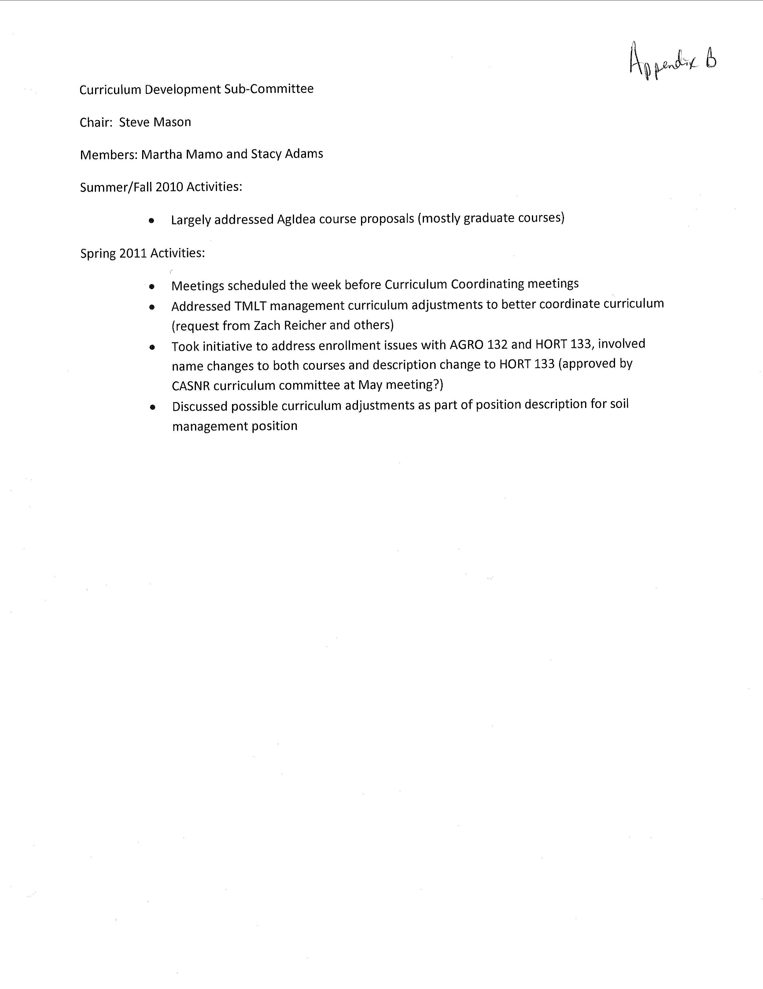
Appendix C
Appendix D
CASNR CC Update, May 25 Annual Meeting
From Dr. Martha Mamo
Following are requests and/or information updates on items relevant to our program:
- There were 2500 sub and waivers (highest to date in total and per student) in the 2010-2011 academic year. Dan Husmann provided a listing (attached) for units to look and sort out the common sub-waiver. This way, it can be programmed into DARS by Gail to avoid paperwork. Carol can provide the electronic copy for sorting and processing. Dennis, I assume you will handle this?
- AECN 141 has changed its course description adding that the course is open ONLY to freshman and sophomores. This may or may not be programmed into My Red, it will be up to Ron Hanson. It is not clear how transfers will be handled. An alternative course is suggested for students who are beyond to take ECON 212. As advisers we need to be aware of this and suggest to our incoming students to take AECN 141 in the freshman and sophomore level. This will be in place Fall 2012.
- Questions for Plant Science 132 and 133. I informed the CCC that the two courses are essentially similar with focus being on Agronomic crops in 132 and Hort crops in 133. The experiment requirement in 132 will be listed in Italic. The committee questioned whether or not there is such experiment for 133 as well if A&H wanted to keep consistency. I suggest that Steve and Stacy address the questions below so it is clear to the CCC before it proceeds forward
  - Is Plant Science 133 offered in Fall and Spring?
  - Is there a similar plant experiment for 133? If so, should that also be noted in the bulletin?
  - If 133 is similar to 132, should it be listed in the College core? Right now, Core lists 132, 133 can be added as “OR” assuming the experiment is already in place. I am not sure if this means that 133 to be certified as ACE 4 (?).
  - Suggest providing the most recent course syllabus of 132 and 133 to Carol.
- AGRI 105 (Ag Literacy) course development on hold until CASNR gets a clear direction on the best approach for this. Also, how AGRI 103 will be taught, designed and integrated a follow up course with 105 is still under discussion.
- The issue of curriculum rigor was raised by Dean Waller. I shared with the CCC that A&H is rather looking at how to prepare our students for success rather than rigor. I and other shared the need to seamlessly integrate the skills to think with content and information across the entire curriculum (science literacy, solving problem, using data to support argument, systems approach etc..). There will be a CASNR CC sub-committee with invitation from IANR FAC to discuss and outline pressing undergraduate curriculum challenges and opportunities by June 30, in time for the 2025 IANR retreat in July. Some of you may be called to participate in this pre-retreat discussion. I believe this will be an important discussion as we may be looking at a paradigm shift in our undergraduate education enterprise.
- Distance education certificate process is in progress. The MOA between UNL and UNK is underway. To make financial transaction simpler, the UNK teacher will request adjunct faculty in the A&H department. Ellen may know more about this. The other Ag-IDEA Hort courses have moved forward and waiting graduate Council approval
- Good news. I have requested that CASNR CC support having the writing center on EC campus. Since we had discussed this at the A&H teaching retreat and also have the student area across Goodding available for our writing consultant. Dean Waller will write a letter in support of this. If approved, we will have the writing center in our building for Fall and Spring. I assume the working hours will be determined in the future. I also suggested that the staff be students from our campus who have the agriculture and natural resources context. If approved, please advise faculty to utilize this resource center so we can justify having them around during the academic year.
- CASNR Core communication area was discussed. Revisions will be made to list only courses approved as ACE 1 and 2.
- Information on distance education issue-Post Secondary Institutional Act Title 4 Financial program will begin requiring State authorization for offering classes to students in other state. Any distance course that has students from other state will need this permission. Dean Waller provided this as information. The details of who will write and when is still in the works. ADEC seems to be involved in this process
- National Survey for student engagement data was send to A&H sometime ago. CCC will like to obtain feedbacks/reactions from faculty. Markwell will resend this data.
- Finally, I will be co-chairing the CASNR CC with Gina Matkin for 2011-2012 academic year. Because of my teaching load in the Fall, Gina will direct meetings in the Fall and I in the spring. Gina and I will work closely both semesters.

Appendix E

May 20, 2011

Memorandum

To: Gail Meyer, DARS Coordinator
From: Lloyd Bell, Agricultural Education – Teaching Option

Re: Undergraduate listing, subject area endorsement in Horticulture Education

The home department for managing the horticulture education subject area endorsement is the Department of Agricultural Leadership, Education and Communication (ALEC), in close collaboration with the CASNR Department of Agronomy & Horticulture for subject area advice. ALEC teacher education faculty will facilitate official endorsement processing through the UNL teacher certification office within the College of Education and Human Sciences.

Suggested copy for the Ag Ed catalogue section within CASNR.

Horticulture Education endorsement requirements

If the student desires to add a subject area endorsement in horticulture education to their teaching certification, the following course work should be completed.

Horticulture Education (Grades 7-12). 33 hrs. Program Planning, ALEC 400 or 413 3 hrs.; Soil Resources, HORT 153 4 hrs.; Plant Science, HORT 131 3 hrs, and Introduction to Horticultural Sciences Laboratory HORT 133 1 hr.; Landscape Plants I, HORT 212 3 hrs. or Landscape Plants II, HORT 213 3 hrs.; Plant Propagation, HORT 221 3 hrs.; Greenhouse Practices & Mgt., HORT 325 4 hrs.; Introductory Turfgrass Management, HORT 227 3 hrs.; Landscape Mgt., HORT 228, 3 hrs.; Floral Design, HORT 261 3 hrs.; Career Experience, HORT 395 3 hrs.
Suggested copy for the Ag Ed field endorsement listing within CEHS catalogue section.
Agricultural Education. Consult the CASNR – Department of Agricultural Leadership, Education and Communication section within this catalogue for endorsement requirements. A combined agricultural education and biology endorsement is also available as well as an independent subject area endorsement in horticulture education.

