2014-2015 Greenhouse Growing of Basil during the Winter in Nebraska

Basil is one of the few medicinal herbs that is an annual. The purpose of our research is to test eight different cultivars for growth and performance under controlled environment agricultural conditions: that is, basic fertigation supplied with a capillary mat, heat under the benches and natural winter light greenhouse conditions. Seeds of eight cultivars were sown in October and allowed to germinate and grow for 5 weeks. Multiple plants were then transplanted into 6-inch pots filled with soilless mix and received one of 3 fertilizer treatments; either just 100 ppm N from 20N-
4.4P-16.6K water soluble fertilizer; 100 ppm N from 20N-4.4P-16.6K plus 6 g of 12N- 3.1P-14.9K slow release fertilizer or 100 ppm N from 20N-4.4P-16.6K plus 9 g of 12N 3.1P-14.9K slow release fertilizer. The experiment design was a RCBD across two north-south running benches with 6 replications. All cultivars germinated within 7 days.
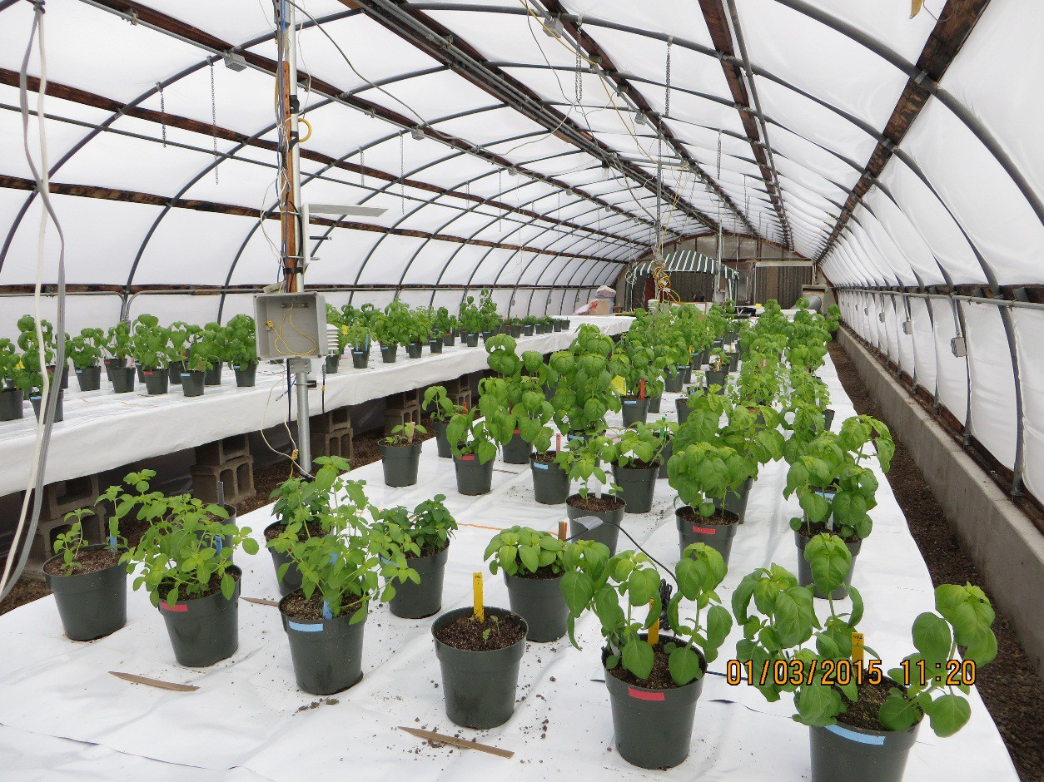
At eight weeks after sowing, plants were pricked out to only 3 per pot.

Fifteen weeks after sowing, one plant from each pot was harvested, dried, weighed and set aside for essential oil analysis.

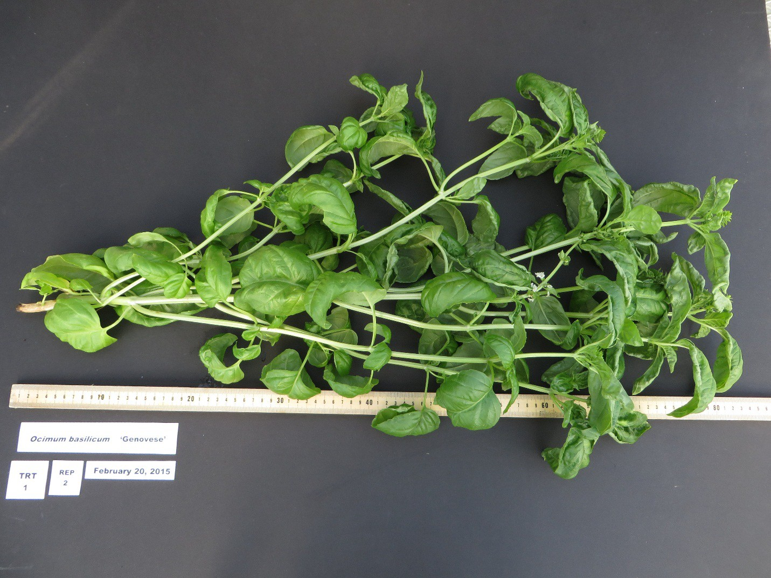

Italian Large Leaf, Genovese and Nufar cultivars had larger leaves than plants of ‘Mrs. Burn’s Lemon’ and ‘Spicy Globe’. ‘Holy’ basil plants, which was the only cultivar with obvious pubescence, took the longest to grow (pricked out at 19 weeks after sowing) and to flower. All other cultivars started to flower between week 12 and 13 after sowing. All plants receiving only 100 ppm N were slower to develop, but eventually flowered. There did not appear to be any growth differences between the other two nutrient treatments. Cultivars Mrs. Burn’s Lemon and Spicy Globe had a bushy habit as compared to the more single-stemmed structure of the other cultivars.

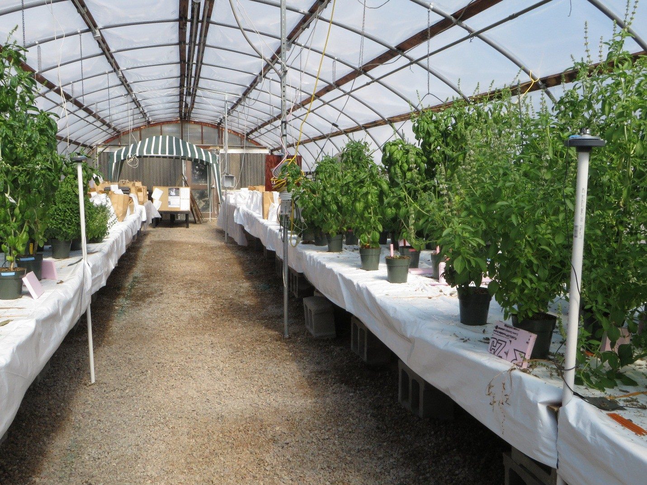

At weeks 19-20, plants of all cultivars except ‘Holy’ and ‘Spicy Globe’ were at least 3 feet tall.

Currently, our third and final harvest is underway. Plant parts will be separated and dried in preparation for weighing and eventual distillation of the oils. Preliminary production timelines for all cultivars are also being created.

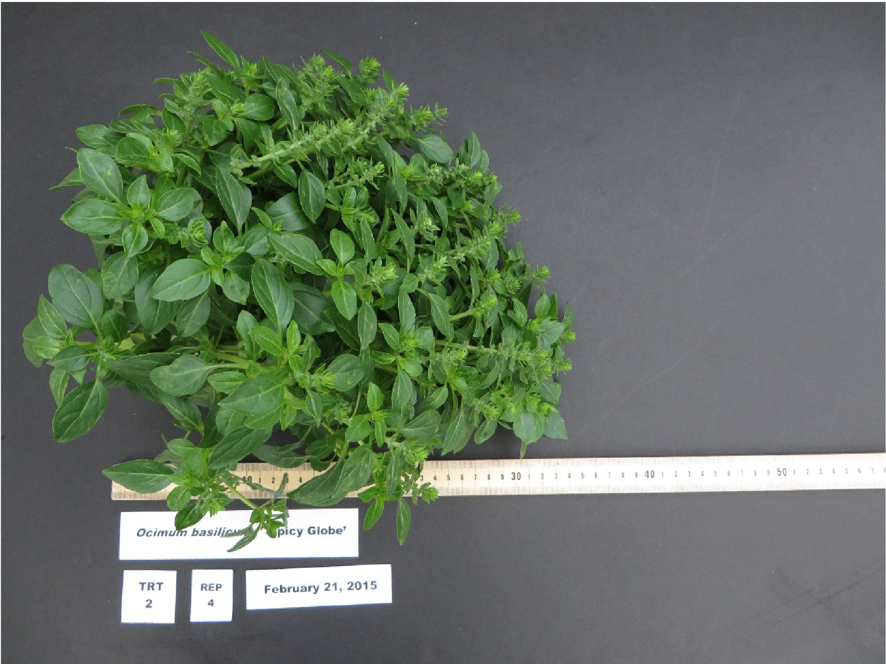

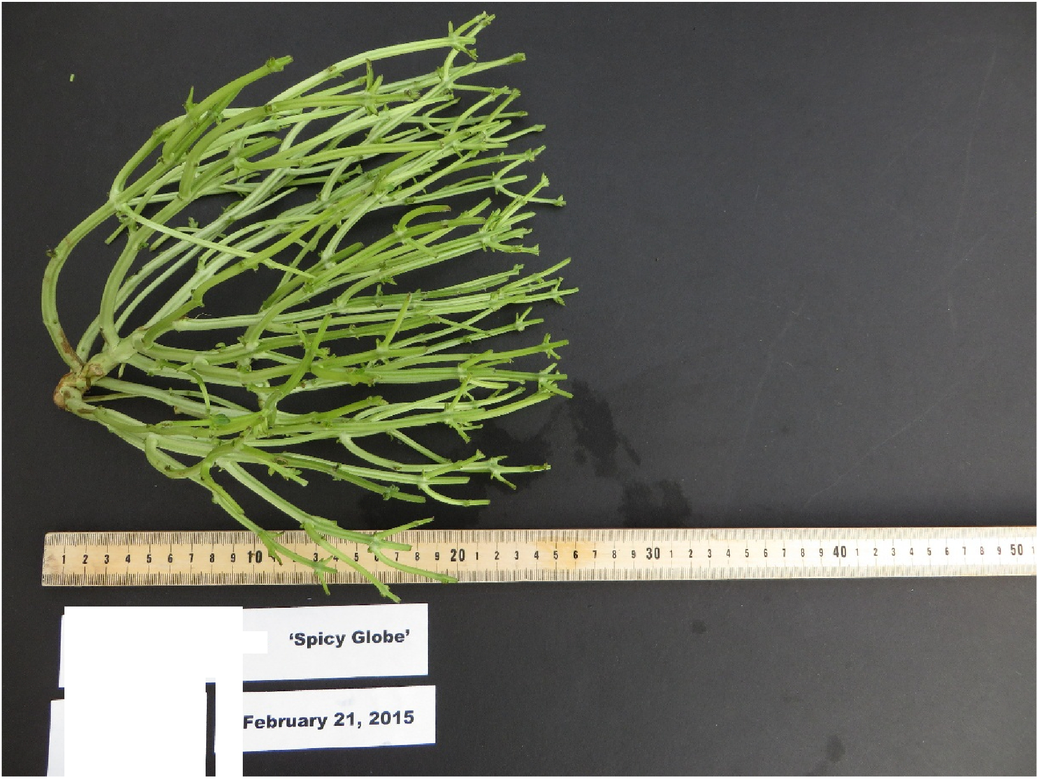
Ocimum basilicum
TRT
2
REP
4

